|  | **FPT ACADEMY INTERNATIONAL**  **FPT – APTECH COMPUTER EDUCATION** |
| --- | --- |

**Centre Name: ACE-HCMC-2-FPT.**

**Address: 590 Cach Mang Thang 8, District 3, Ho Chi Minh City, Viet Nam.**

**[T2H Store]**

| **Supervisor:** | Phạm Thị Lánh | |
| --- | --- | --- |
| **Term:** | 1 | |
| **Batch No:** | T1.2206.M1 | |
| **Group No:** | 2 | |
| **Order:** | **Full name** | **Roll No.** |
| 1. | Đỗ Ngọc Cát Tường | Student1394612 |
| 2. | Lê Quang Huy | Student1352239 |
| 3. | Nguyễn Quốc Huy | Student1363366 |

Month 10 Year 2022

This is to certify that

**Ms. ĐỖ NGỌC CÁT TƯỜNG**

**Mr. LÊ QUANG HUY**

**Mr. NGUYỄN QUỐC HUY**

Have successfully Designed & Developed

**T2H Store**

Submitted by: **Mrs. PHAM THI LANH**

Date Of Issue: Octorber, 2022

Authorized Signature:

# Content

Content 1

Acknowledge

3

**REVIEW 1**  6

Problem Definition 7

Architecture and Design of the project 9

Site map 10

Screenshots 11

I. **Homepage** 11

II. **Sign In** 13

III. **Sign Up** 14

IV. **Product Category/Search Page** 15

V. **Product Comparison** 17

VI.  **Product Detail** 18

VII. **Cart Dropdown** 19

VIII. **Check out** 21

IX. **Contact** 22

X. **About** 23

XI. **List News** 24

XII. **News Page** 25

XIII. **Policy page**

25

**REVIEW 2** 28

I. **Home Page** 29

II. **About Us** 32

III. **Contact Us** 33

IV. **Top 5 Brands** 34

V. **Comparison** 36

VI. **Product Detail** 37

VII. **Cart** 40

VIII. **Delivery** 41

IX. **Sign In & Sign Up** 42

X. **Blogs** 44

XI. **Blog** 45

XII. **Policy Pages** 46

# 

# Acknowledge

As we understand that the eProject is a step-by-step learning environment that closely simulates the classroom and Lab based learning environment into actual implementation. It is a project implementation at your fingertips!! An electronic, live juncture on the machine that allows you to.

✓ Practice step by step i.e., laddered approach.

✓ Build a larger, more robust web design and development.

✓ Usage of certain utilities on the web designed by the user.

✓ Single program to unified code leading to a complete website.

✓ Learn the implementation of concepts in a phased manner.

✓ Enhance skills and add value.

✓ Work on real-life projects.

✓ Give a real-life scenario and help to design and development web more complicated and useful.

✓ Mentoring through email support.

We would like to send a great thanks to our professor and other students for their adorable support during the time in the project.

Besides several mistakes we made in the project, we hope to have more opportunities to widen our knowledge in the web developing world.

We also thank you so much for your information and the “demo” project from India APTECH to help us get a more realistic experience in this project. Since we have gained more experience from this project, we will not stop learning anything as much as we can to be more successful in the future.

Your Sincerely, Team Group 02.

# 

# Synopsis

- The Objective of this program we aim is to give a sample project to work on real-life projects. These applications help us build a larger, more robust web design and development.

- The objective is not only to help us understand more HTML/CSS/JavaScript/AngularJS/JQUERY but also to provide us with a real-life scenario and help us create basic applications using the tools.

# 

# 

# 

# 

# 

# REVIEW 1

## Problem Definition

# Wireless World has years of experience in the international consumer electronics market.

# We have a structured, dynamic, competitive work team, committed to their work and with a great sense of belonging. We permanently innovate in our processes and technology services portfolio in the face of challenging market changes. We constantly bet on new projects to renew our offer and add value to our customers, innovating in products, services, knowledge transfers, and growth. We help our customers obtain the most innovative electronic products, from top brands at competitive prices. We currently have a large inventory with more than 40 leading brands in the consumer electronics and computer industry.

# Understanding that markets change and customers evolve. We help them find comfort when making a purchase.

# We work with products from Samsung, Apple, Nokia, LG, Motorola, Alcatel, CAT, Sony, HTC, Blackberry, Huawei, ZTE, and Xiaomi, among others.

# You are supposed to create a Single-Page-Application and responsive Website for them with the below-mentioned requirement specifications. The website is to be developed for the Windows Platform using HTML5, JSON, Angular JS, JavaScript, and Geolocation. The site should work well in all leading browsers including Chrome, IE, Firefox, etc.

## Customer Requirements Specifications

# The portal will be designed as a Single-Page-Application and responsive Website with

# a set of pages and menus that represent choice of activities to be performed. The

# pages, menus, and other visual elements must be designed in a visually appealing

# manner with attractive fonts, colors, and animations. All of these should also be laid

# out in a responsive manner.

# Depending on the decision given by the management on the Web site to be created

# following are the requirements based on which the website needs to be developed.

# The Web Page should be created with proper sections, graphics, and logo.

# A Menu should be created which would categorize all the information about the features provided on the Site For e.g. a Menu for Various Cell phones, a Menu for Features of Cell phones, etc.

# Page should have sections like TOP Selling Mobile Phone, Best Budget smartphone (Under $200), Best Offers on Mobile.

# The information should be categorized according to the Brand names of Mobiles like if a User wants to see only Samsung Phones then move to Samsung section and similarly for Top 5 Brands. Rest other brand phones should be listed under All Mobile Phones section.

# The features of Individual phones should be displayed on the Web Page along with the Cell phone images.

# User should be able to select maximum three mobile devices to compare. Comparison section should also be there where there is Phone comparisons done with various models of same brand or various models of various brands.

# The Comparison information should be provided in Tabular format comparing the features of different phones.

# The Colour Schemes should be soothing, more of Pastel Colours can be chosen for the same.

# When a particular brand phones are being displayed the background image of the Web page should show the Logo of that brand for e.g. if Samsung Phones are being displayed then that page should have the Logo of SAMSUNG as the background image and the same in case of other Brands.

# About Us, Site map, Gallery, Contact us link must be added.

# There would be two types of users: registered and non-registered users.

# Registered Users should be able to add products to cart.

# Non-Registered users should only view the products on the site.

Over and above this, the portal should implement the following functionalities:

* Display a continuous scrolling ticker at the bottom of the page with current date,
* time, and location (hint: Use geolocation features of HTML5).
* Display a visitor count at the top right corner of the page beside a logo image.
* The menu options should change color on hover and also after clicking.
* Fade in and fade out options can be used for the menus.

# 

## Architecture and Design of the project

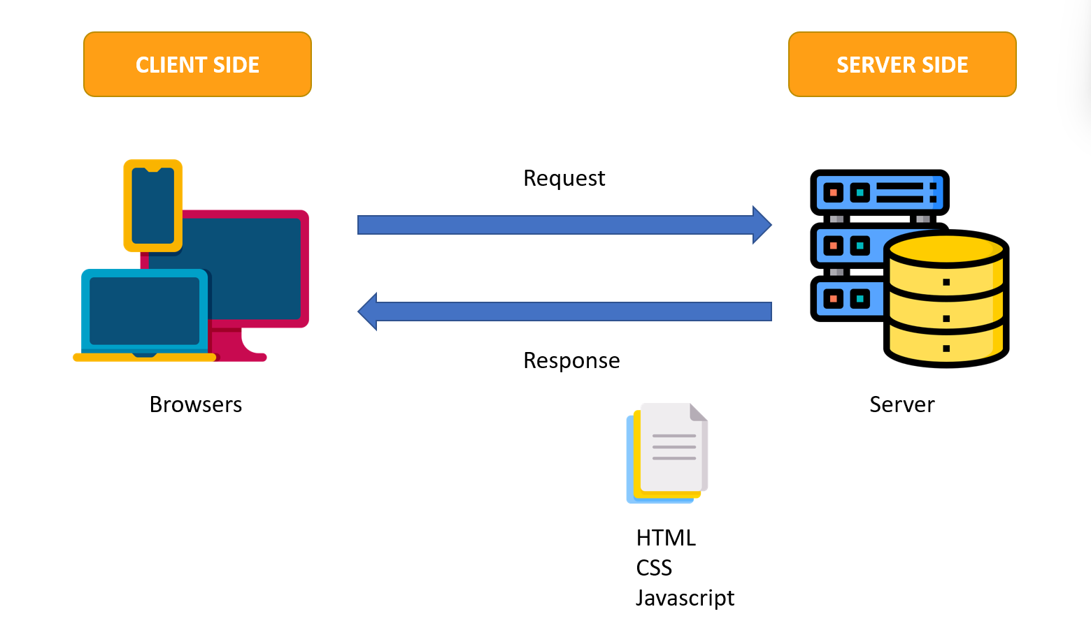

## Site map

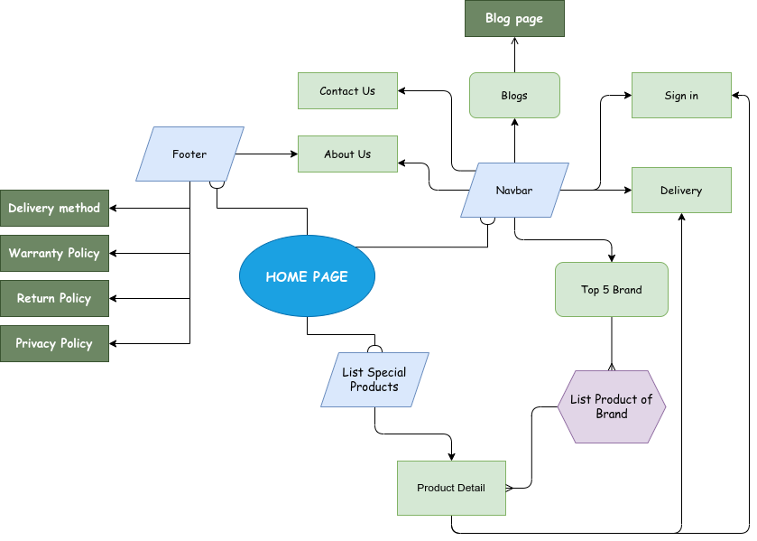

## Screenshots

1. **Homepage**

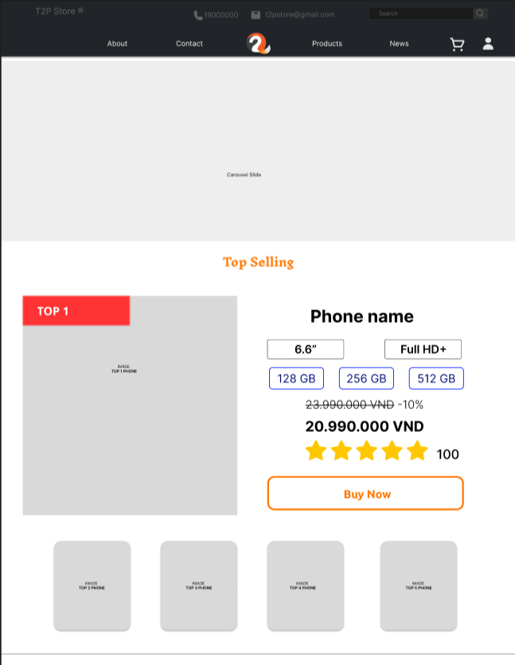

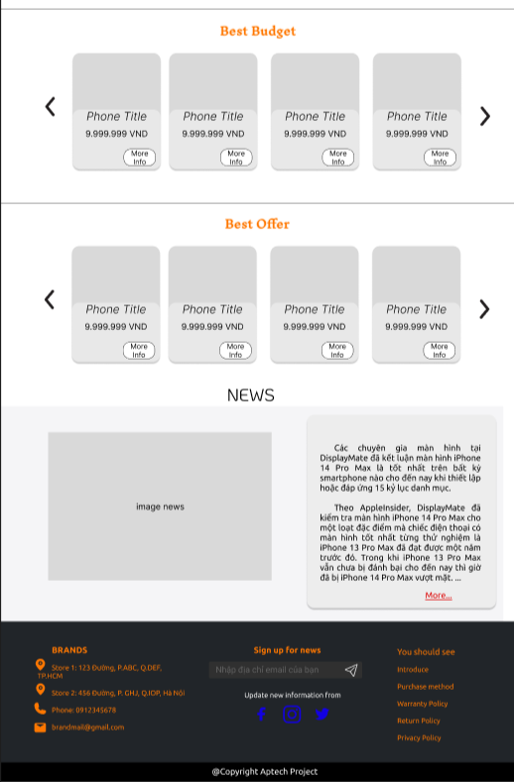

**Description:** This is a homepage of T2H Store, the top of this page is a header after that is a navigation bar. The main part of the homepage beside the slider also includes 3 sections: hot seller, best sellers, best budget, and news. The footer has links to subscribes, information pages, purchase methods, policies, and contact information.

1. **Sign In**

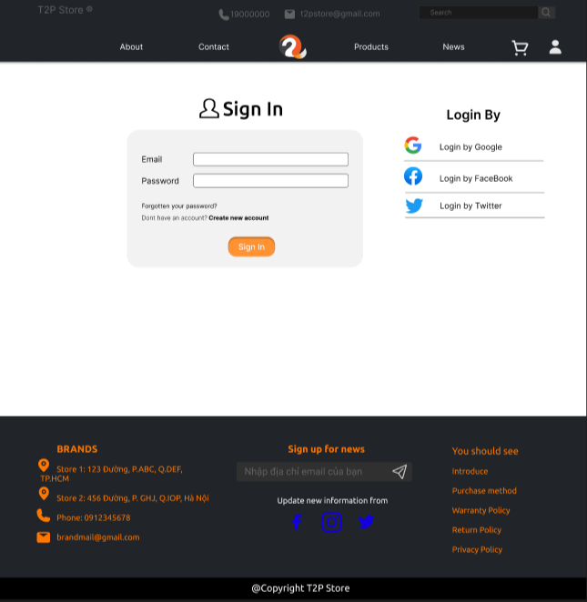

**Description:** When the user clicks on the human icon in the header, it leads to a sign-in page. This form requires the user to enter an email address and a password. After clicking the Sign In button, the user will be redirected to the homepage.

1. **Sign Up**

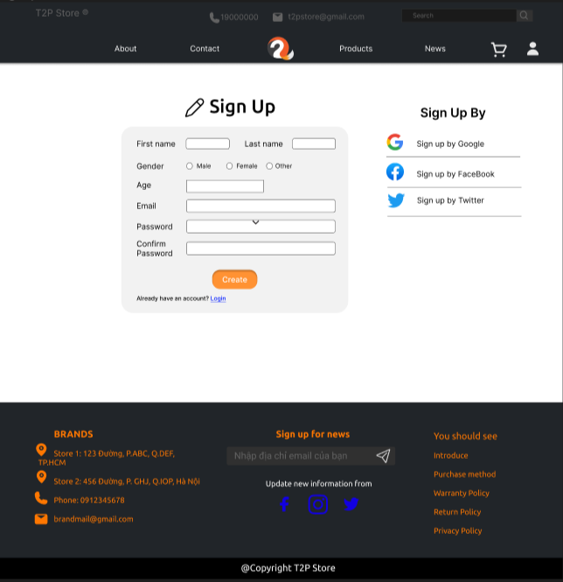

**Description:** If the user hasn’t created an account, they can click to “Create new account” in the **Sign-in** page and it will lead to this **Sign-up** page. This sign-up form requires the user to enter 4 fields: first name, last name, gender, Age, email, password and confirm password. After clicking the Create button the user will be redirected to the homepage.

### Product Category/Search Page

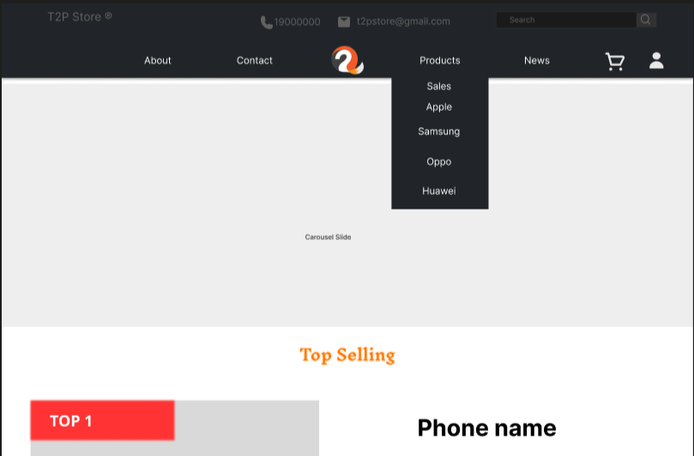

**Description:** When users mouse into Products in the navigation bar, it will show up a list that contains links to get into sales items and brand products. Or the user can click on Products to get a list of all items the store has. After users click on any brand name or sales or products to list cell phones, The user will get to the list page which will describe below.

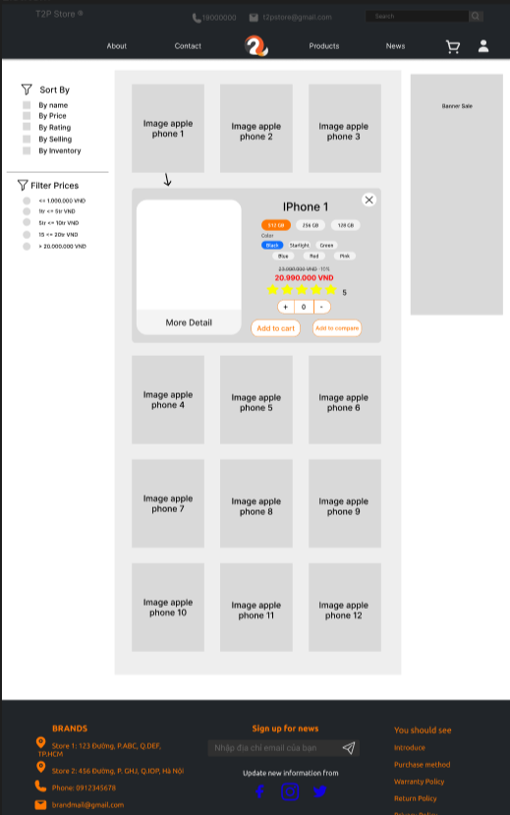

**Description:** A list of cell phones about the brand user choose or sales products that the store has will show up. On the right side, we have many selectors for users to filter cell phones by brand, or order by name, price, rating, ….. When the user chooses any cell phone, a small description of that cell phone will show up below it.

### Product Comparison

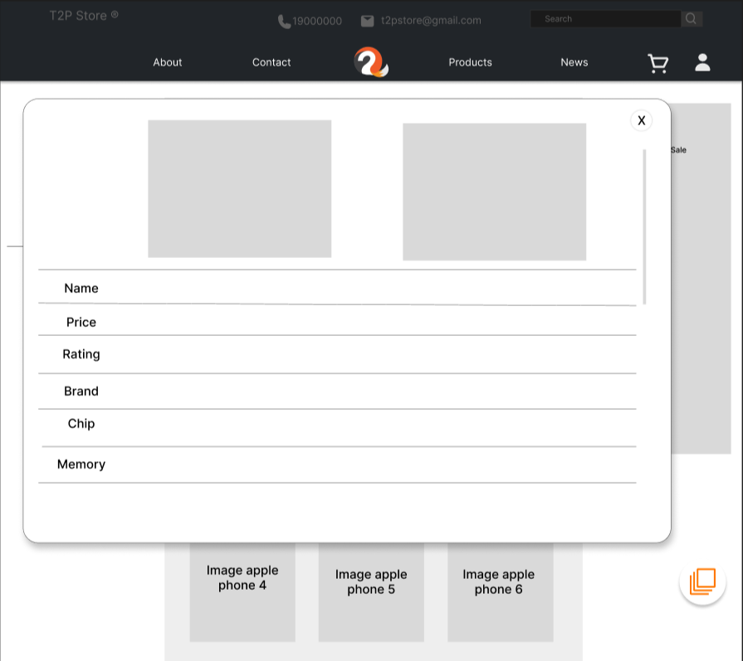

**Description:** If users want to compare 2 items, they can click on Add to compare, and after one item was be clicked, a circle will appear in the bottom right of the site, then after the user choose another item that they want to compare, they can click on the circle, a pop-up will show, it will show 2 cell phone detail.

### Product Detail

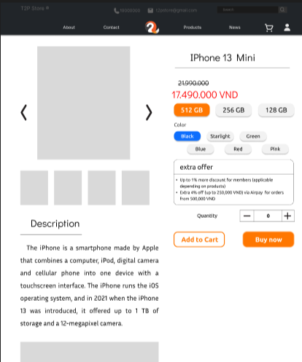

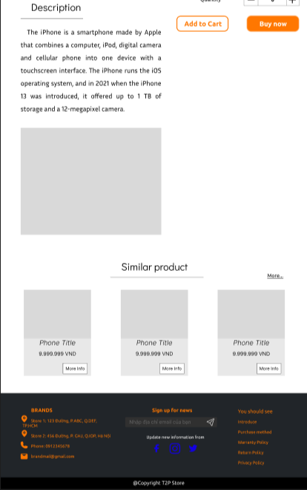

**Description:** In the list of cell phones, users can mouse into the picture of the selected cell phone, and there is a small div showing up with content in more detail. After clicking on the picture of the cell phone, redirect to the Product detail page, in there, users can see more detail describing that cell phone, which also shows up what type and color of the phone that user wants to buy. After choosing, the user can choose “Add to cart” or “Buy now” to get it into the cart or redirect to the Checkout page. Below the cell phone detail, the page shows users more related phones.

### Cart Dropdown

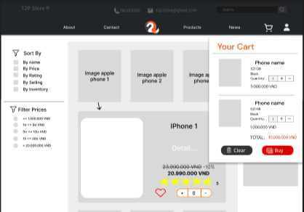

**Description:** When the user clicks on the cart icon in the header, the cart information will appear. It includes products that users have already added to the cart, the user can select all items or remove items that they don’t have the intention to buy.

### Check out

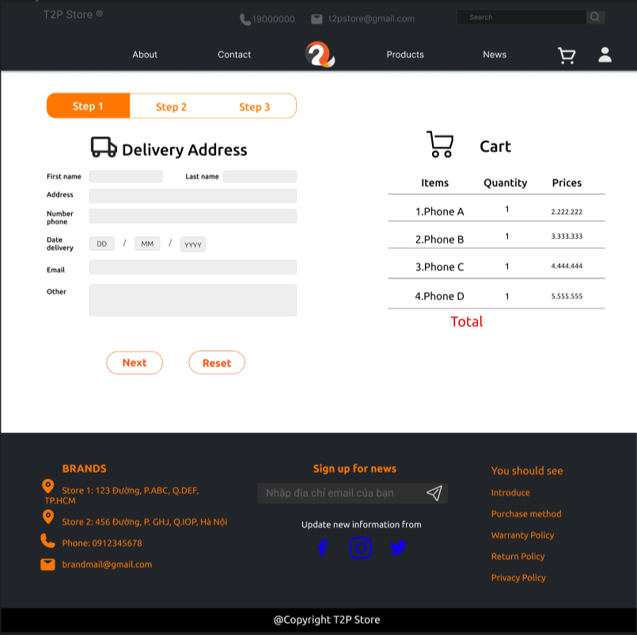

**Description:** After clicking the Check out button on the Cart or Buy now button on the Product Detail Page, the user will be redirected to this checkout page. The left part of this page contains a form that requires the user to enter and the other side is the Order summary.

Step 1: Users finish the form about information of users and delivery information.

Step 2: Users choose a payment method.

Step 3: Finish payment. It will show up all information about delivery that the user input and all items the user choose.

### Contact

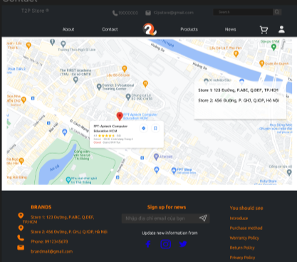

**Description:** After clicking the Contact tag on the navigation bar, the user will be redirected to this page. The main part of this page is a map, beside it is a detailed location of Bright World’s Branches.

### About

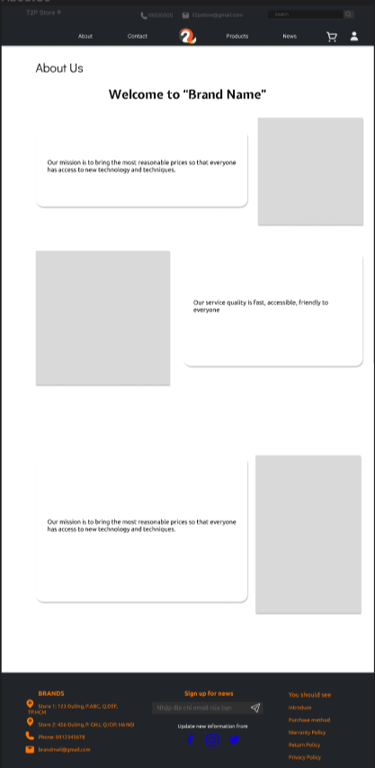

**Description:** After the user clicks on the About tag on the navigation bar, it will lead to this about page. This page contains detailed information about Bright World.

1. **List News**

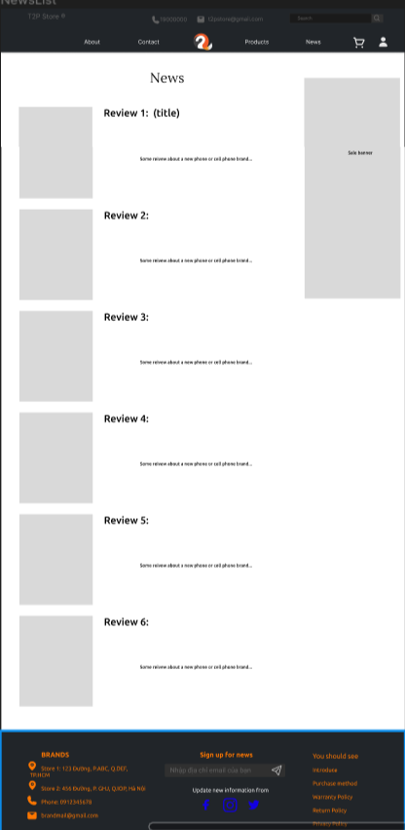

**Description:** After the user clicks on the News tag on the navigation bar, it will lead to the List news page. This page contains some news about the new cell phone or reviews about any cell phone.

1. **News Page**

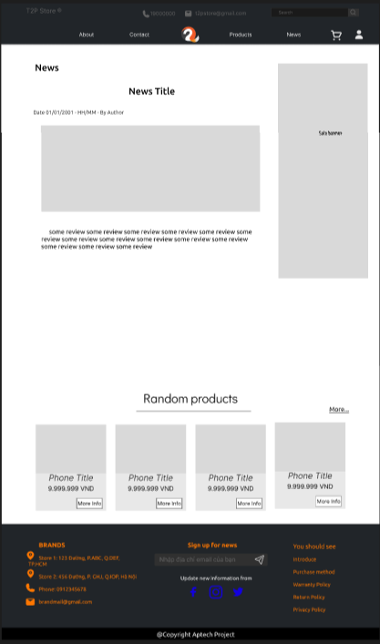

**Description:** After the user clicks on any News in the list news it will lead to the news page. This page contains content about that news.

1. **Policy page**

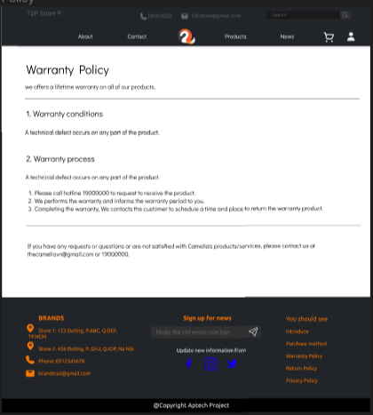

**Description:** After the user clicks on any Policy in the footer or Payment method. The Policy page will show up, and which each policy, the content will be different.

## Task Sheet

| **Project Ref No.** | **Project Title** | **Activity Plan Prepared by** | **Date of preparation of Activity Plan** | | | |
| --- | --- | --- | --- | --- | --- | --- |
| **Task** | **Actual Start Date** | **Actual Days** | **Teammate Names** | **Status** |
| Brainstorming ideas for layouts and Project Object | | Tường  Quang Huy  Quốc Huy | 01/10/2022 | 1 days | Tường  Quang Huy  Quốc Huy | Completed |
| Draw site maps, and architecture design | | Tường  Quang Huy  Quốc Huy | 02/10/2022 | 1 days | Tường  Quang Huy  Quốc Huy | Completed |
| Wire framing general page layout | | Tường  Quang Huy  Quốc Huy | 04/10/2022 | 3 days | Tường  Quang Huy  Quốc Huy | Completed |

**REVIEW 2**

1. **Home Page**

Home page is the front page of T2H Store. Users can return to the Home Page by clicking on the T2H Store logo or selecting the Home page.

Home page contains: a slide introducing new and hot phone products of the store that the store has, 1 item introducing Top 5 best selling phones in T2H store, 1 section introducing the phones with the lowest selling prices, 1 section on the eight phones with the highest votes, highest ratings and the most popular Blogs news section.

Users can go to detailed information about the phones introduced in the first slide of the Home page, or click the Buy Now button in Hot Selling or More Detail in the products listed in the Best Budget, Best Offer,

When the user selects Read more in the News section, the user will be directed to that Blog page.

In the small products listed in the Hot Selling section, when the user selects one of those products, the basic information of that product will be displayed above instead of the original default Top 1 position.

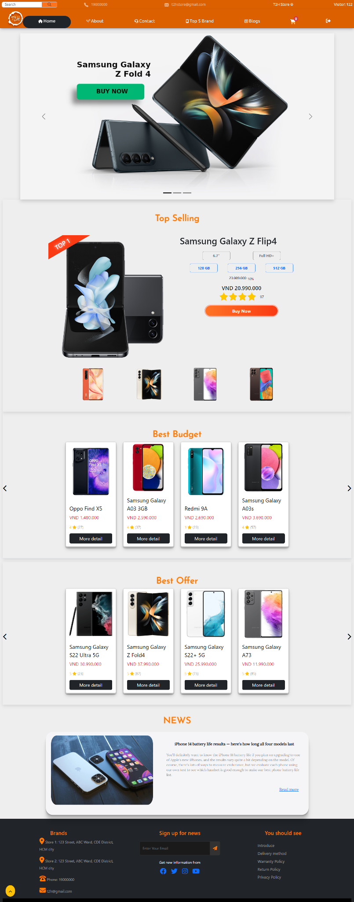



1. **About Us**

About us is a general introduction page about the website, purpose, and mission of T2H Store. The page also contains a sitemap.

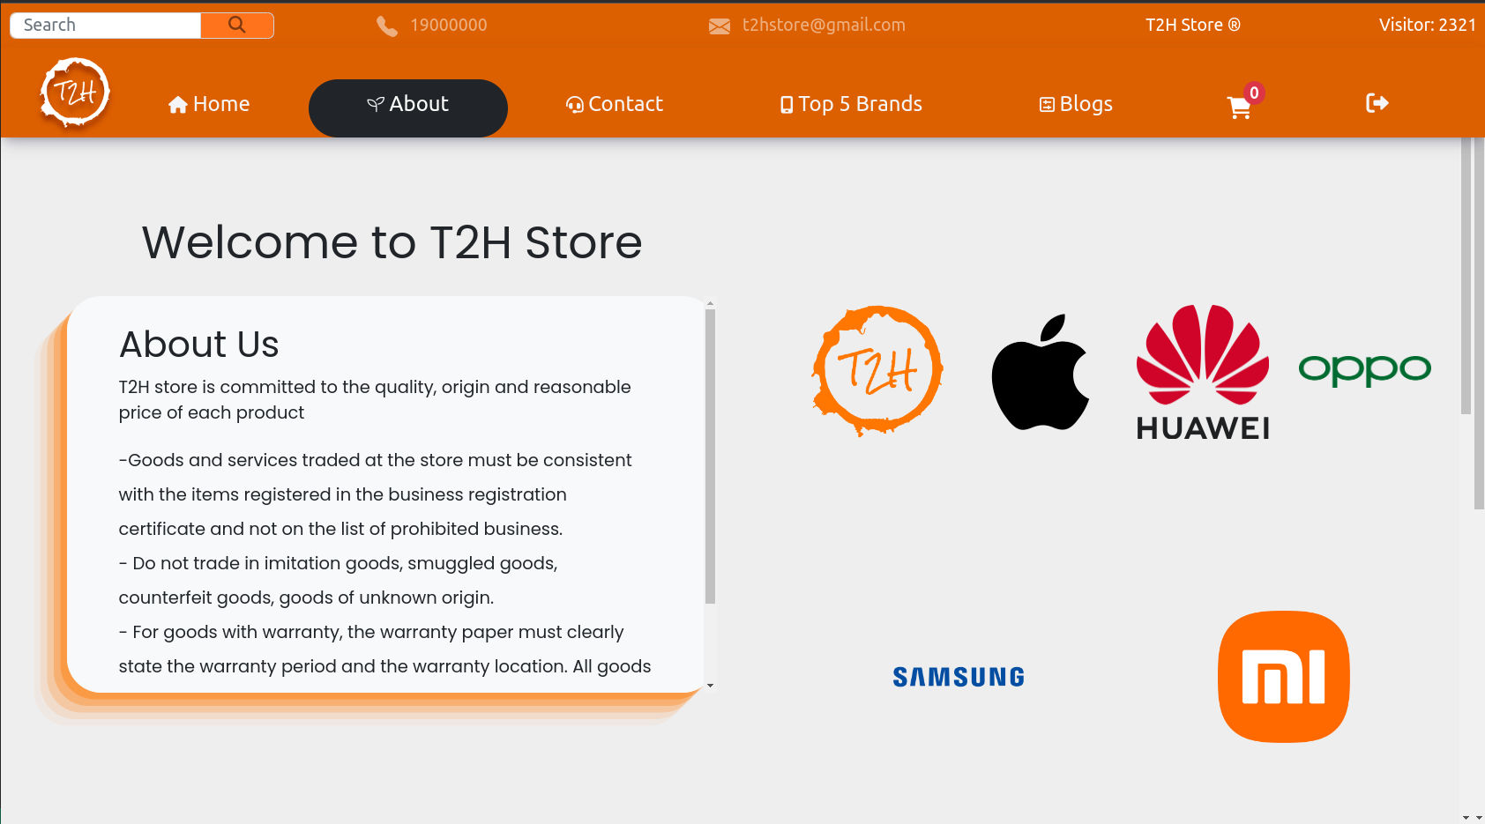

1. **Contact Us**

Contact Us is a page where customers can contact as well as conveniently send email inquiries to T2H Store. The page contains a large map describing the location of the T2H Store.

Users can send mail directly to T2H Store using the Contact form. Customers can only send mail when filling in First name, Last Name, Email, and Message.

On the map, when the user clicks on the location marked on the map, the specific address, Phone number, Email of the T2H Store will appear in the lower right corner of the screen.

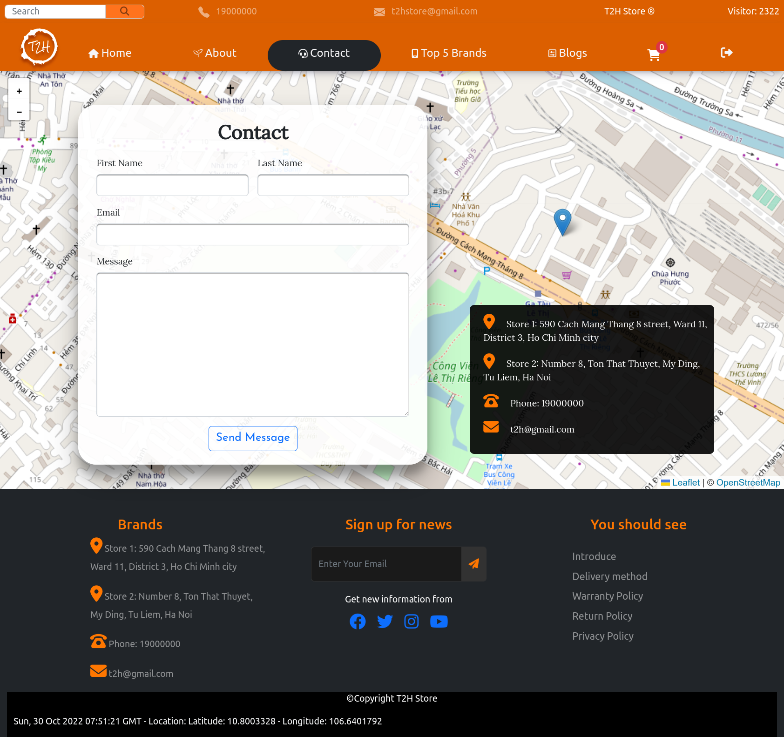

1. **Top 5 Brands**

When the user selects the Top 5 Brands item on the Navbar, a list of the top 5 phone brands of the T2H Store will appear, in addition to the All, All will point to the page containing all the phone models. for sale in T2H Store.

When users choose 1 of 5 phone brand items: Apple, Samsung, Oppo, Huawei, Xiaomi. Users will be taken to a page containing a list of phone models that the T2H store has for that phone company.

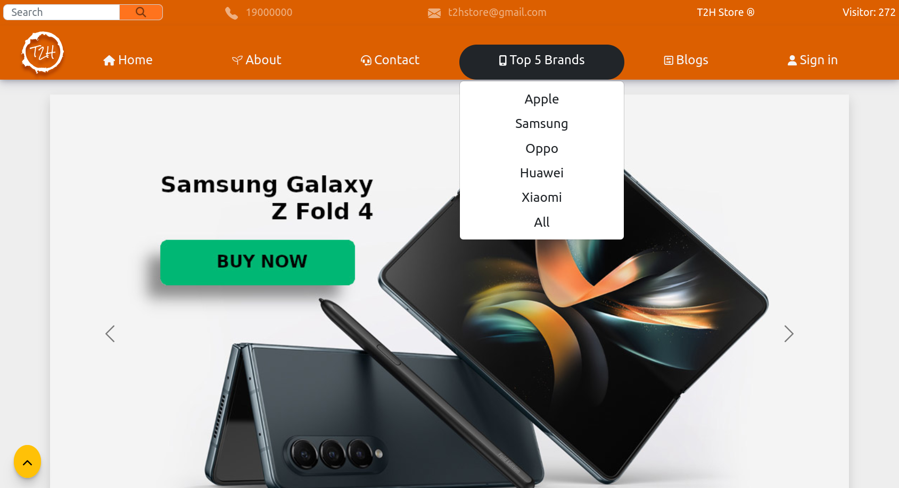

In the page listing Brand or All phone models for all phone models, users can Search for phone models, or Sort by Prices, Rating, Selling, Sales. Users can filter phones by different price points.

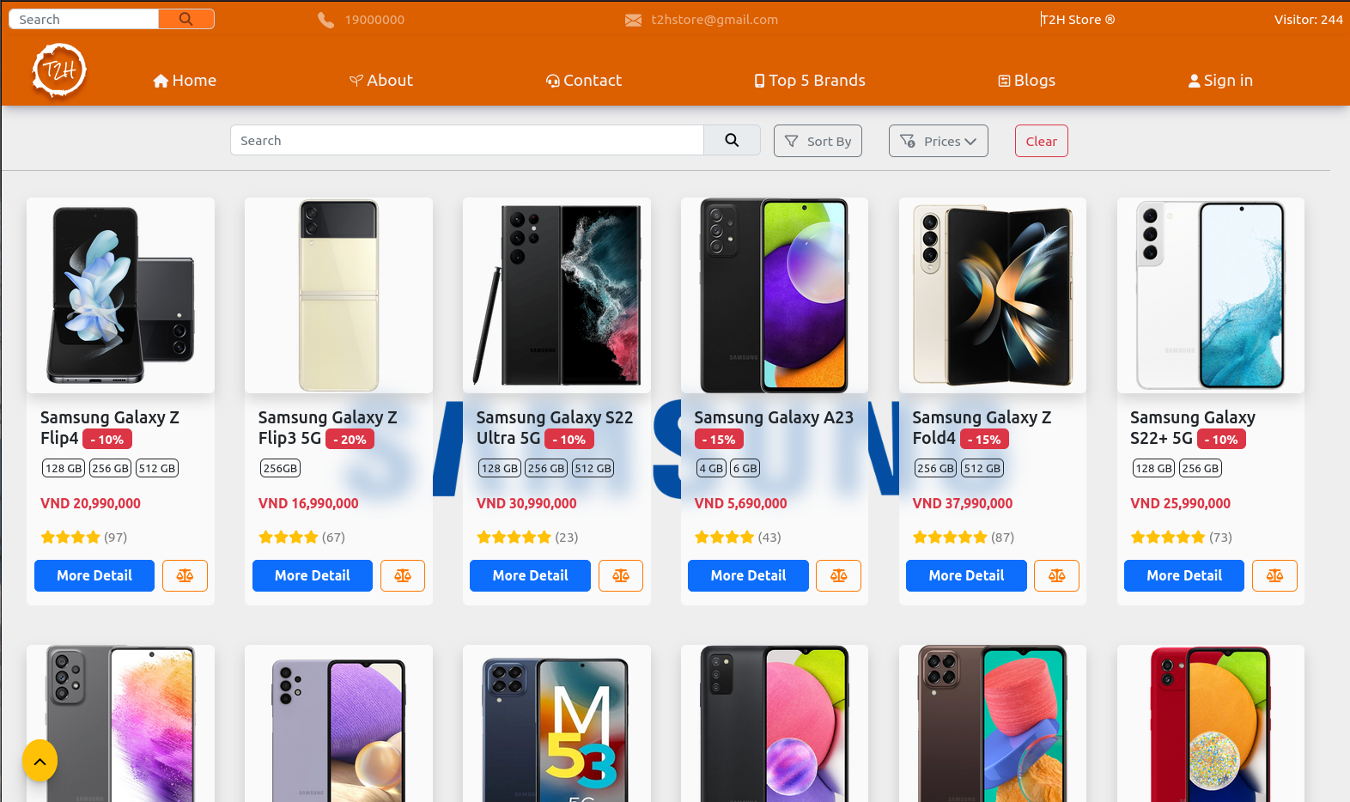

When the user clicks on the image of a product, a popup template contains basic information, this template helps customers to choose to buy the product quickly without going to the product details page.

Users can choose the amount of capacity, and color. The default selected product is the product with the lowest capacity value, color, if the customer does not choose, T2H Store will randomly deliver the color. Customers can choose to add 1 product to their cart using the cart button, or select an existing product to compare by clicking the compare button next to the cart button. User can go to the product detail page by clicking on product image in this popup template.

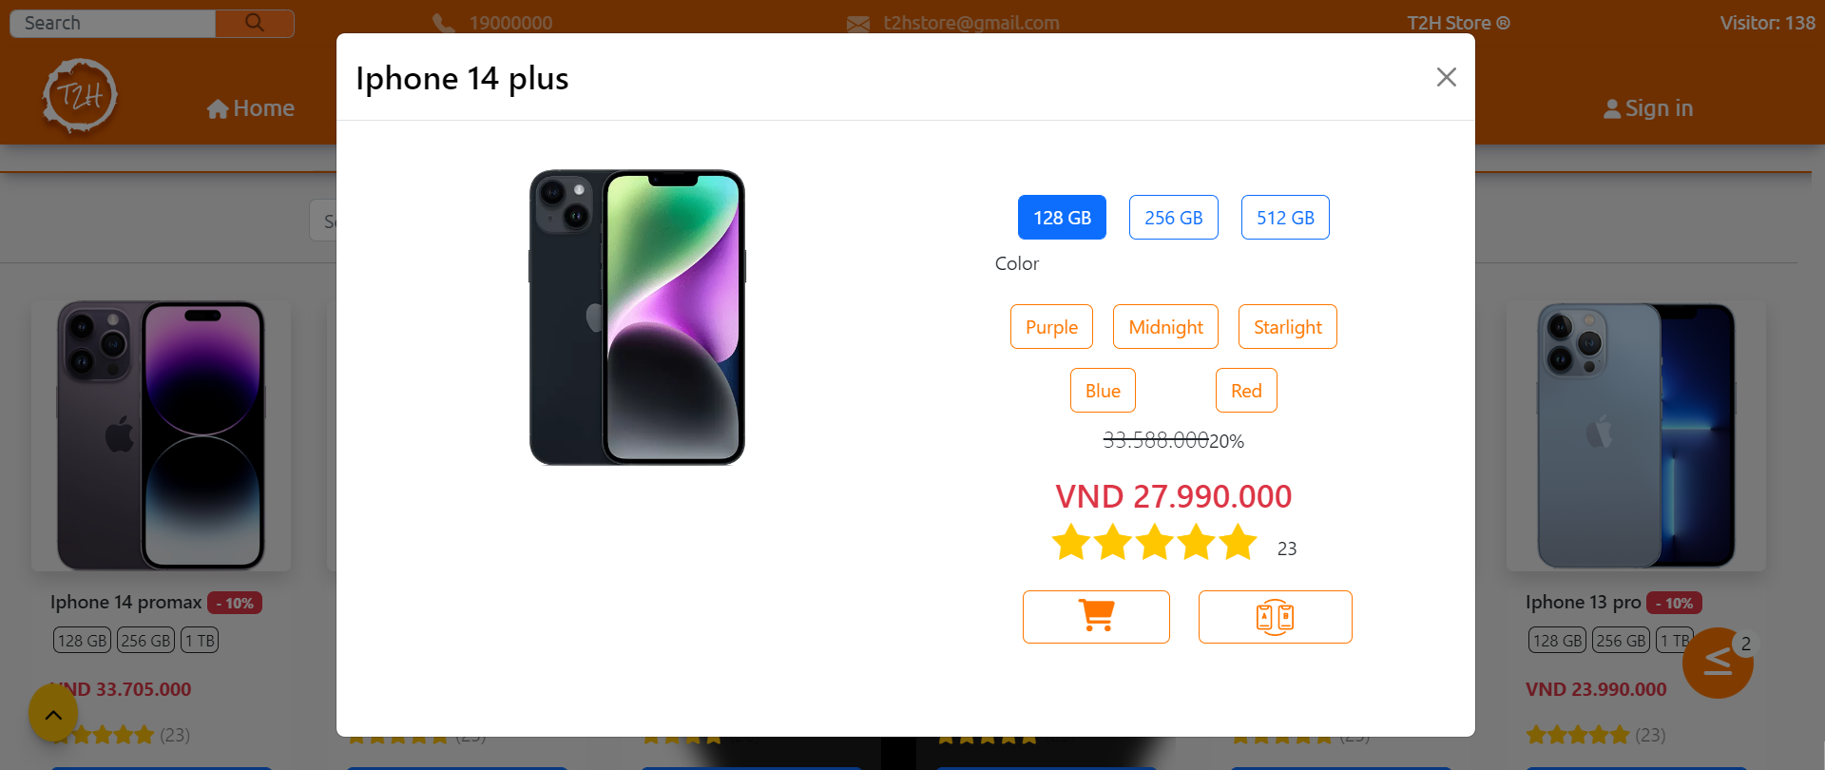

1. **Comparison**

When the user clicks the compare button on the Product Listing Page or the product's popup template, that product is added to the Comparison List. There must be at least 1 product selected for comparison, the orange compare button at the bottom right corner of the screen appears. And users can only select up to 3 products to compare.

If the user selects more than 3 products or selects a product model already in the current comparison list, an alert message will appear for 3 seconds in the bottom middle corner of the screen.

When the user clicks the button, the comparison list is displayed (bottom right corner). A popup template will appear. This table will show the characteristics that differ between phone models (the same characteristics of all comparison models will not be displayed).

The user can delete a comparison sample by clicking the (-) button in the last row of the comparison table. Or select Clear to remove all phone models from the comparison list. Note that after removing all products from the comparison list, the comparison table and compare button will be hidden.

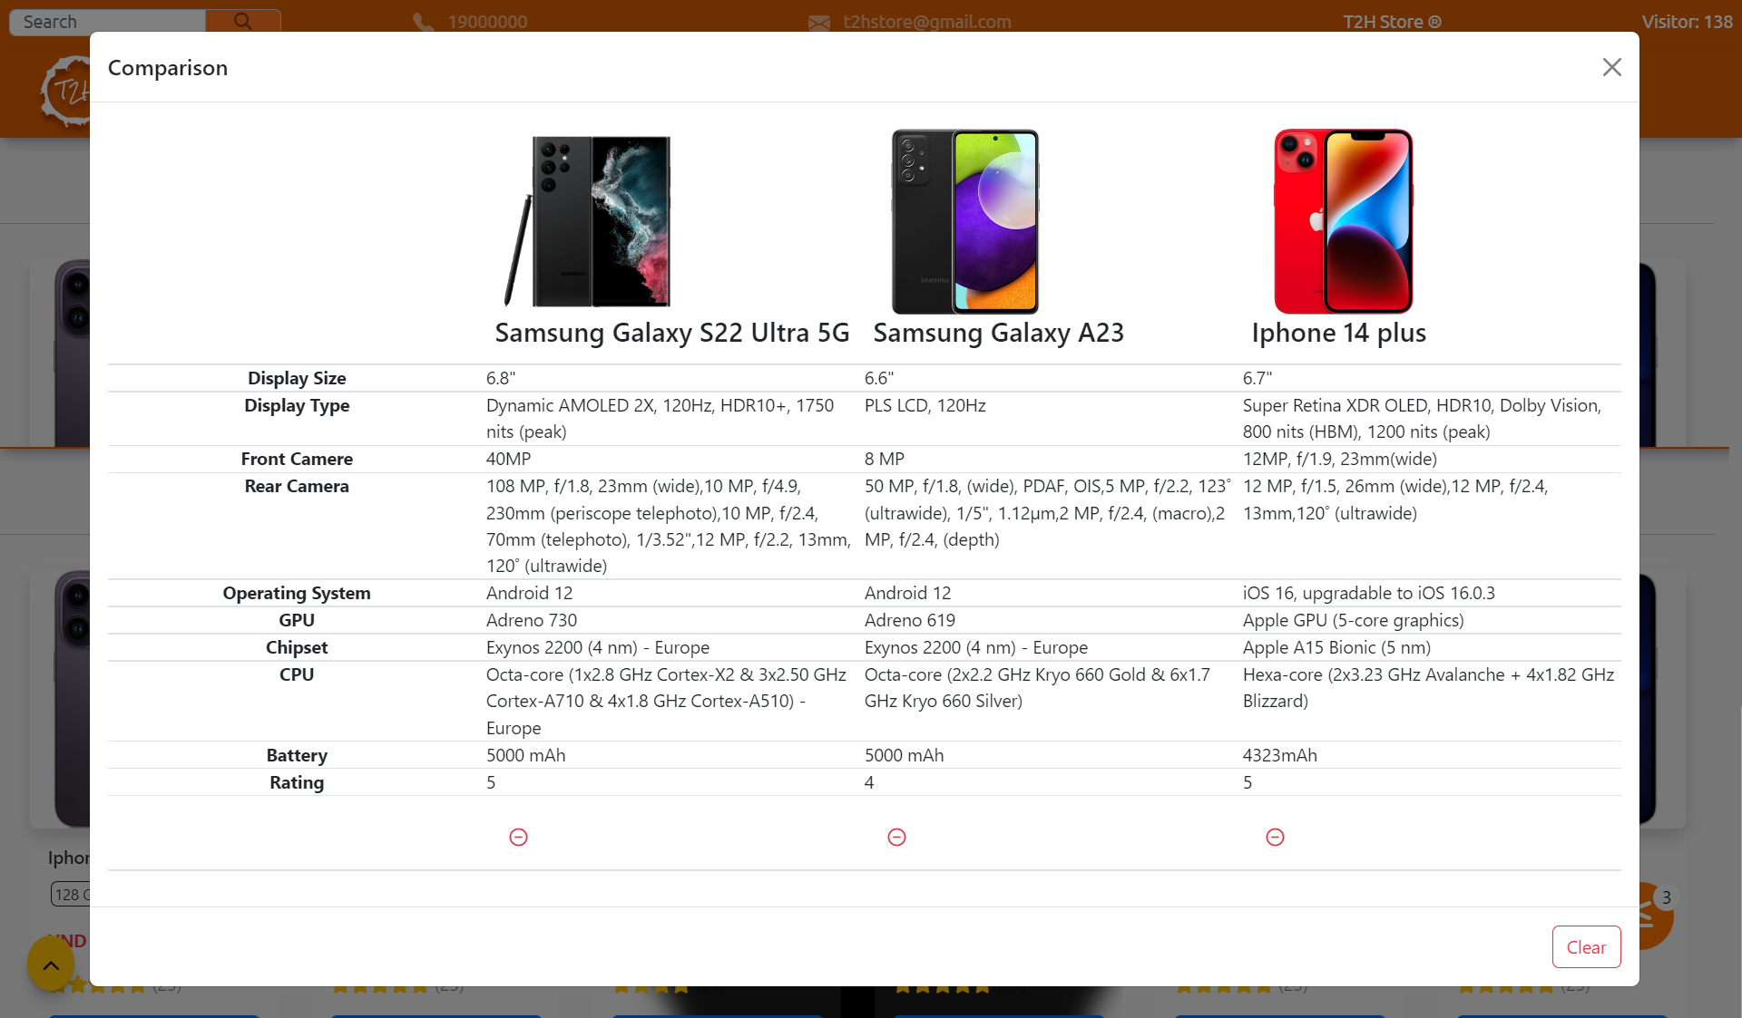

1. **Product Detail**

Although there is no direct link in the Navbar, users can easily go to the detail page of a specific product by clicking on most of the images or the name of a specific phone product in the page. T2H Store web.

Product Detail contains all the information related to the product that the user has selected.

Users can view a short description of the product in the Description or select Detail to see a list of the parameters of that phone.

Users can choose to buy products by choosing the capacity type and color. The capacity type is necessary because for each capacity type there will be a different price category.

Users can choose to buy products in the maximum quantity with products in stock.

When the user selects Add To Cart, the product will be added to the cart.

When the user chooses to Buy Now, it will lead to the Delivery page.

Logged in users, they can comment on products

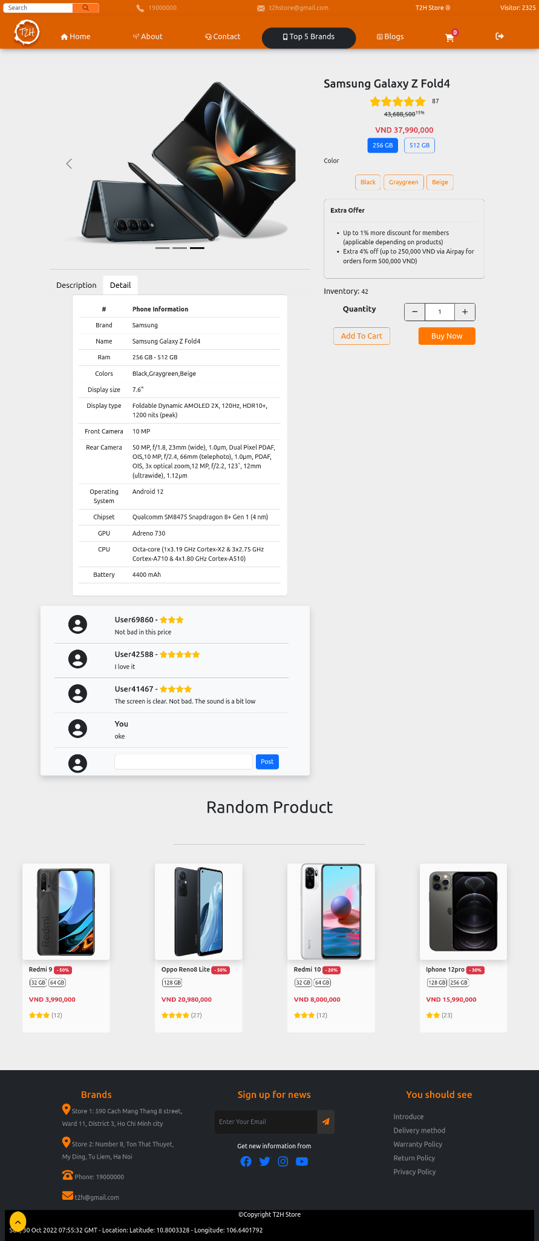



In addition, the Product Detail page will also show 4 random phones in the T2H phones at the bottom of the Product Detail page, on the Footer.

User can go to product detail page in random list by clicking on product image.

1. **Cart**

The list of products that the user has selected to buy (by clicking the Add To Cart buttons) will be displayed by clicking the cart button in the Navbar. Note: The shopping cart button and the Sign Out button are only displayed when the user has successfully logged in or registered an account in the Sign In and Sign Up page.

In the shopping cart list displayed via Popup, the user can choose to add a product by clicking (+) or remove a product by clicking (-), or if the user wants to remove all of their quantity. 1 product (remove it from the cart list), the user can tap on red (x).

The total amount will change for each (-),(+), or (x) click. The total remaining stock of that phone model will also change in the Product Detail page.

The Clear button is used to delete all products in the product list.

The Buy Now button leads to the Delivery page.

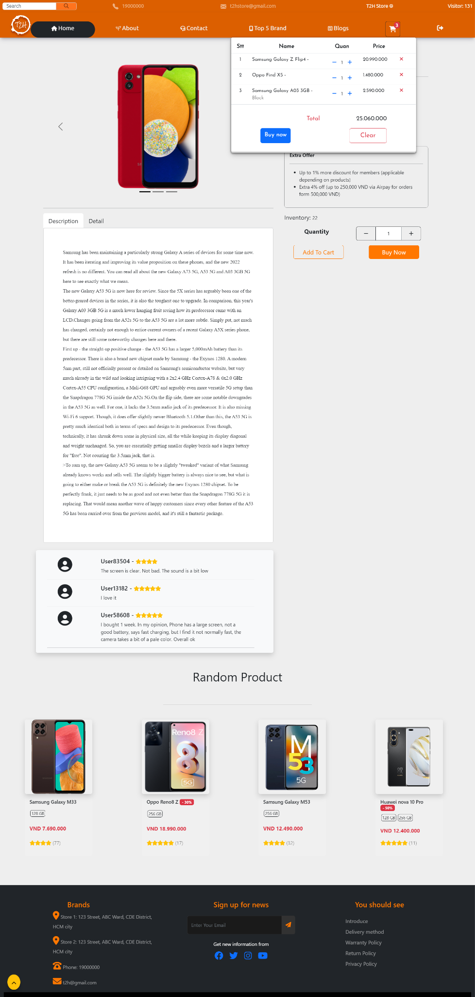

1. **Delivery**

The Delivery page includes 2 main contents: list all products in the cart, and enter the shipping address.

In the list of products in the cart, the user can remove the selected product from the cart. In addition, users can choose to return to the Home page.

There are 3 steps in the shipping address entry. First, the user must enter all information including First name, Last name of the consignee, Delivery address, Recipient's phone number, Delivery date, Email, users may not need to enter Other because these is sub-notes. After fully entering the user can press the Next button to go to Step 2 or select the Reset button to re-enter the delivery information.

In step 2, the user will choose a payment method, there are 2 payment methods: Online or Cash. After selecting the user can press the Submit button to send the delivery information to the T2H Store.

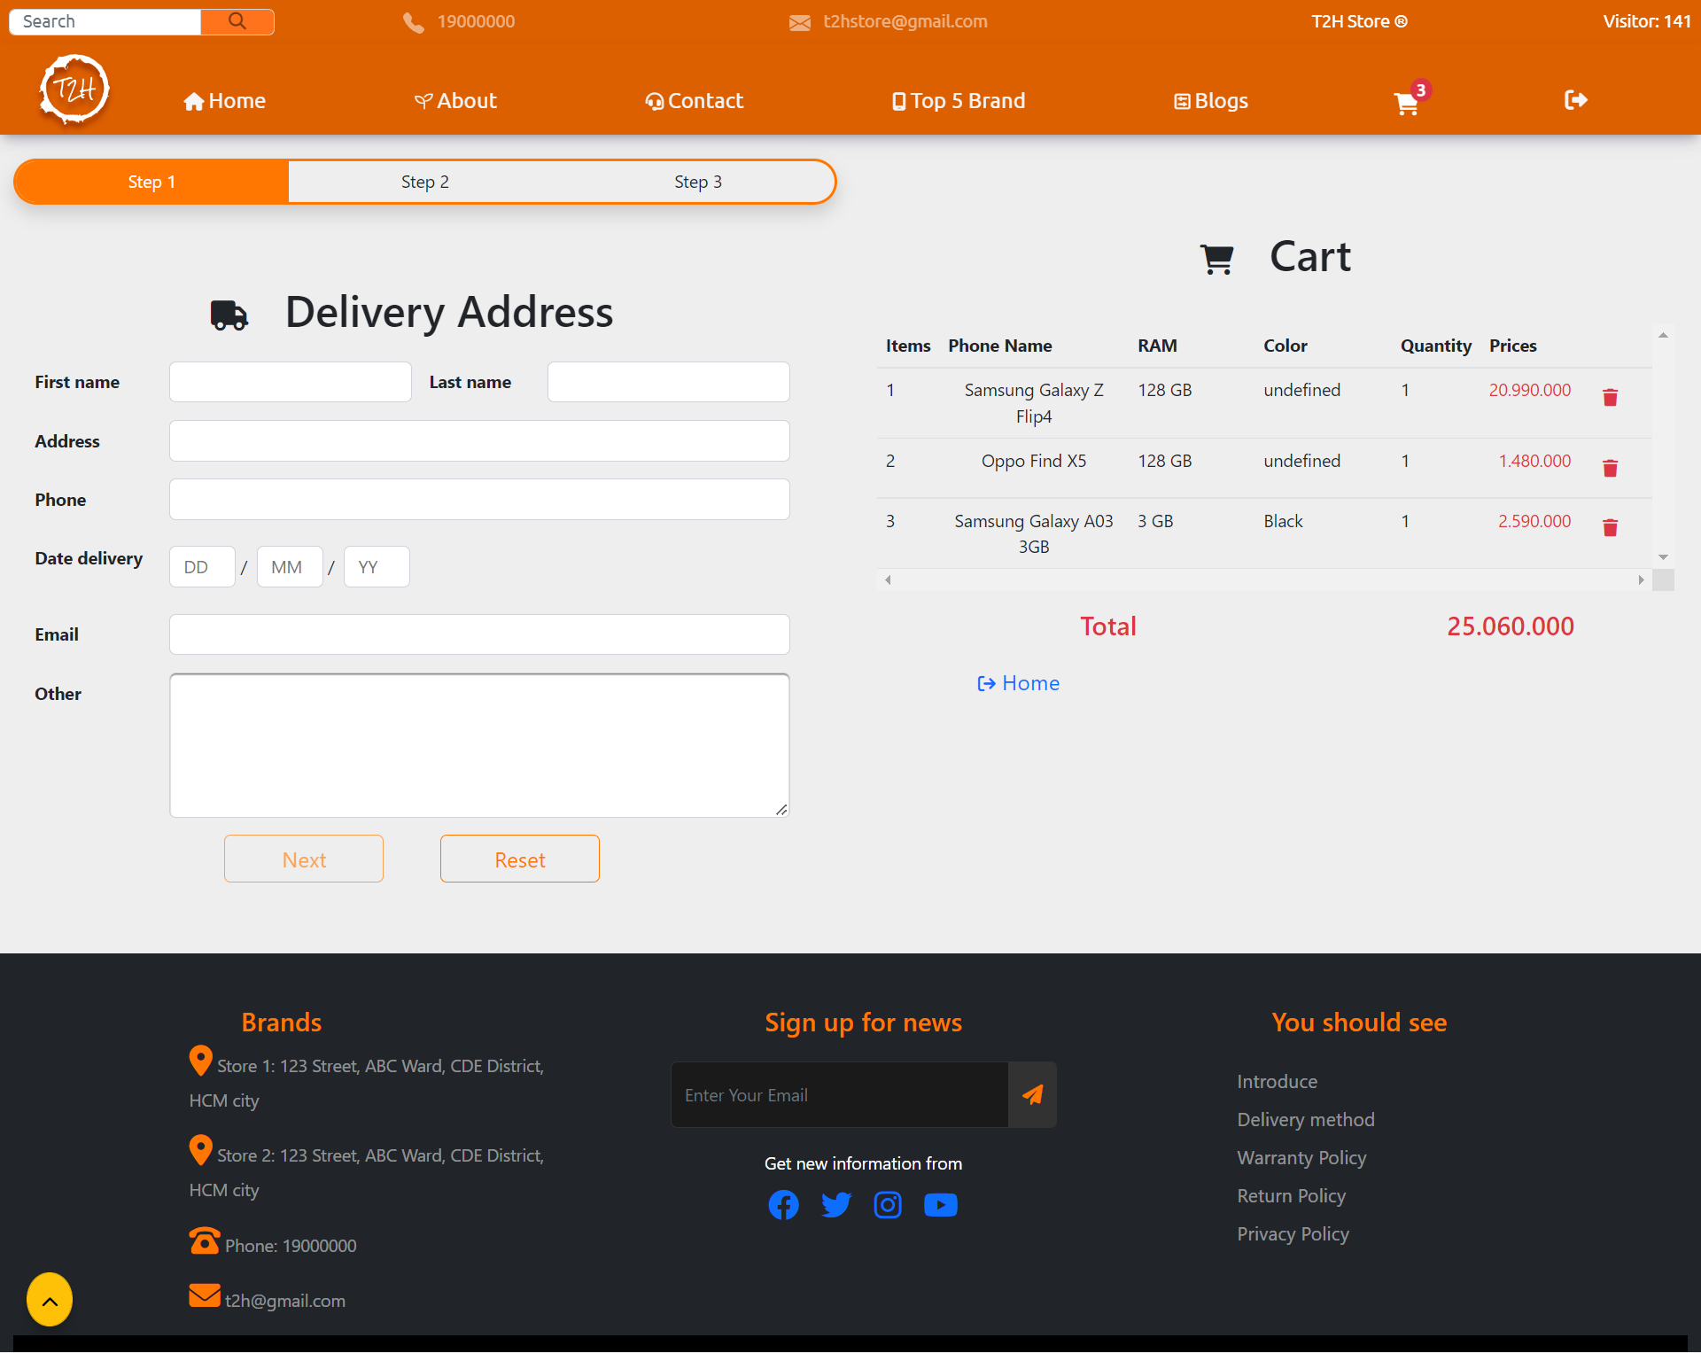

1. **Sign In & Sign Up**

As in the Cart section, we mentioned that users need to log in or register for an account to be able to add products to the cart.

We provide 1 default account to log in is

username: aptech

password: aptech

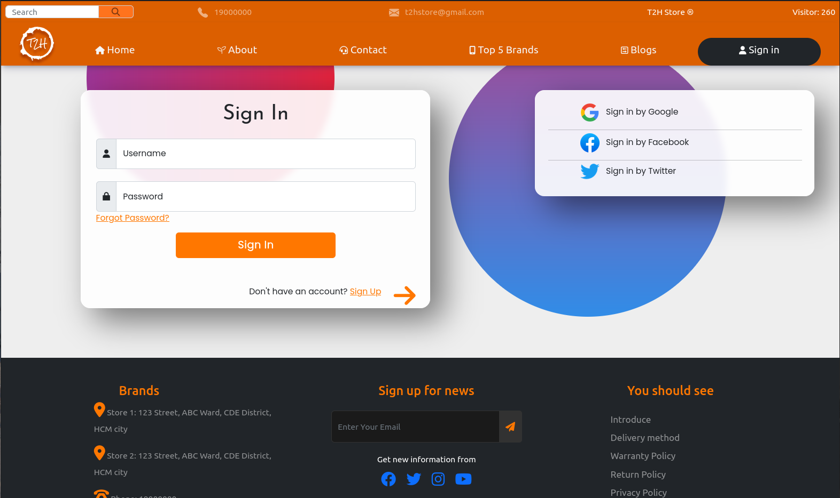

Users can click on the Sign Up link or the sign ( -> ) to go to the Sign Up section.

To register for an account in T2H Store, users need to enter all information in the registration form.

Age asks to choose numbers

Password requires at least 6 characters including letters and numbers, with at least 1 uppercase character

Confirm Password must be the same as the password entered.

After successful registration, the user will be redirected back to the Home page and can perform the Add To Cart function.

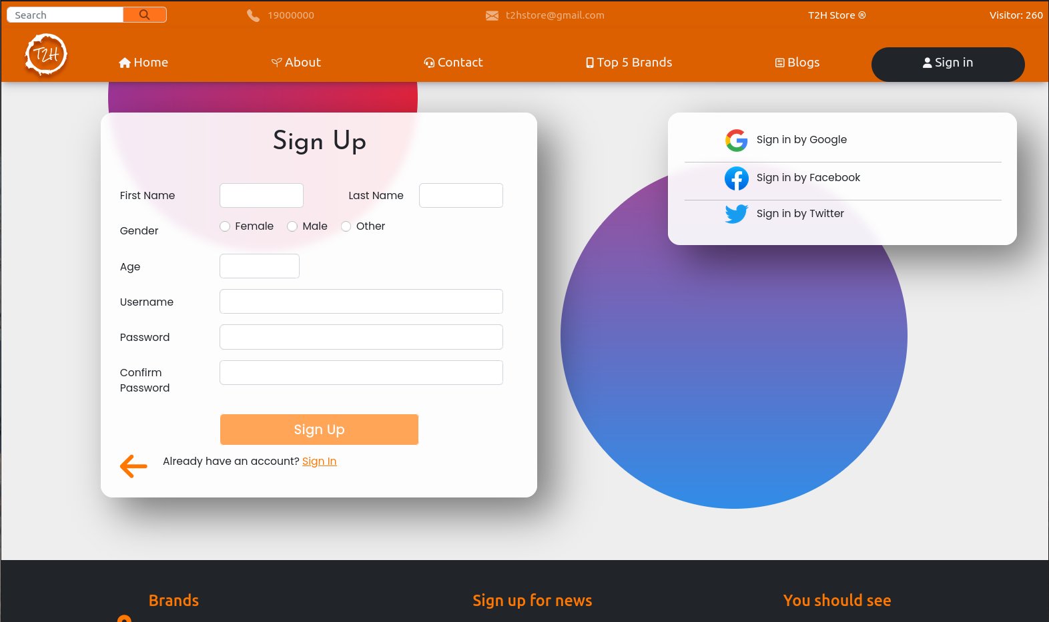

1. **Blogs**

Blogs is a site containing Blogs Reviews about mobile phone models.

Users can go to the Blog page by clicking on the image of the Blog post that the user wants to see or clicking on some title or Read more.

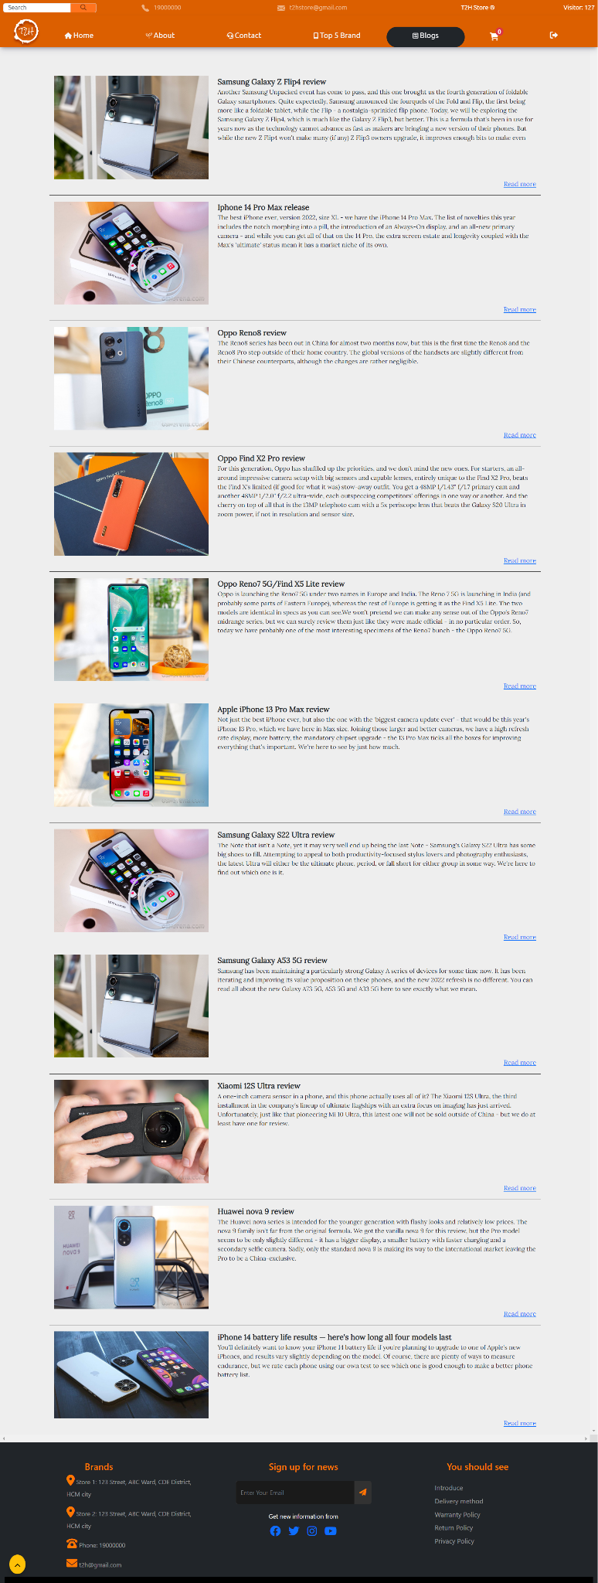

1. **Blog**

Blog page is the page that displays the contents of the Blog post.

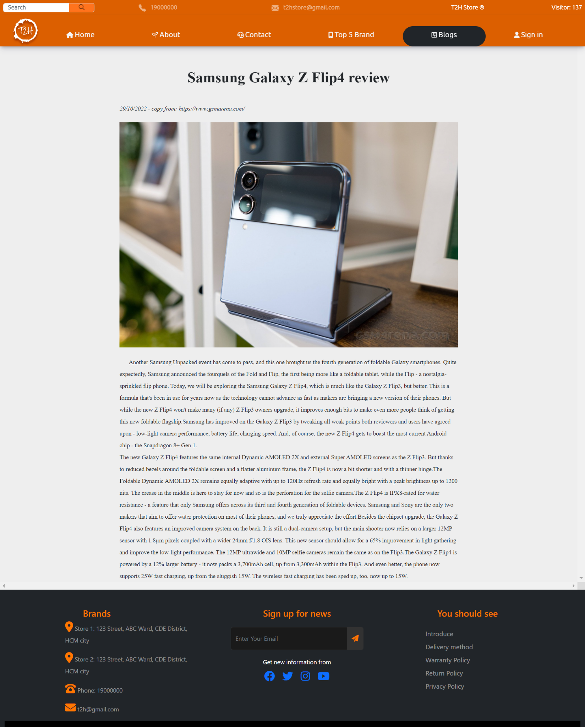

1. **Policy Pages**

Policy Page is a page containing information about T2H Store's policies, terms, methods, and services. The page has simple content, users can go to this page through the page link in the Footer.

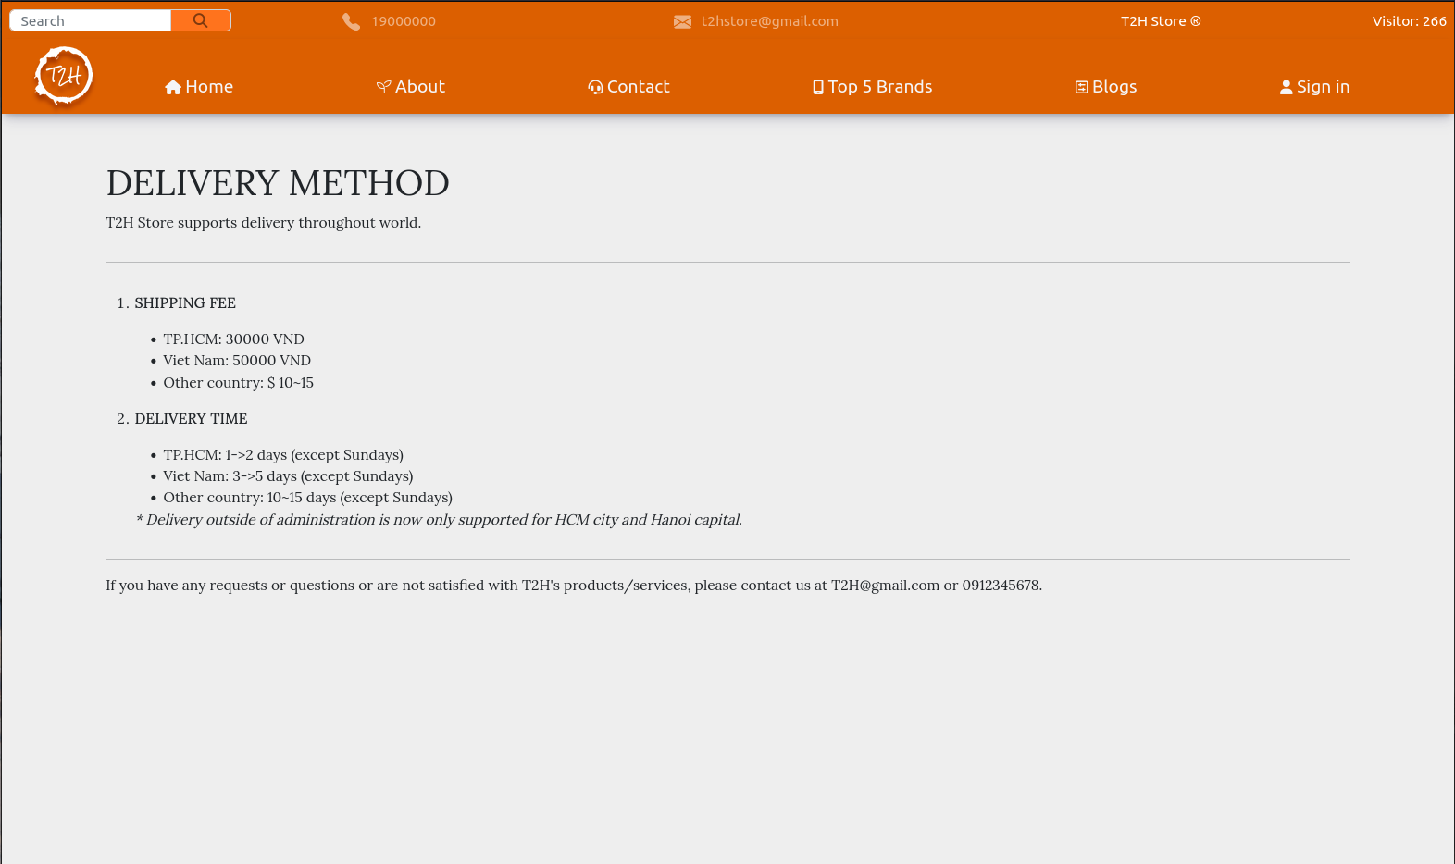

## **Task Sheet**

| **Project Ref No.** | **Project Title – Ask Me Mobile** | **Activity Plan Prepared by** | **Date of preparation of Activity Plan** | | | |
| --- | --- | --- | --- | --- | --- | --- |
| **Task** | **Actual Start Date** | **Actual Days** | **Teammate Names** | **Status** |
| Brainstorming ideas for layouts and Project Object | | Tường,  Quang Huy,  Quốc Huy | 01/10/2022 | 1 day | Tường,  Quang Huy,  Quốc Huy | Completed |
| Draw site maps and architecture design | | Tường,  Quang Huy,  Quốc Huy | 02/10/2022 | 1 day | Tường,  Quang Huy,  Quốc Huy | Completed |
| Wire framing general page layout | | Tường,  Quang Huy,  Quốc Huy | 04/10/2022 | 3 days | Tường,  Quang Huy,  Quốc Huy | Completed |
| Collect static assets (pictures, documentation,…) | | Tường,  Quang Huy | 06/10/2022 | 2 days | Tường,  Quang Huy | Completed |
| Design & Build Homepage | | Tường,  Quang Huy | 09/10/2022 | 3  days | Tường,  Quang Huy | Completed |
| Design & Build Sign in | | Tường,  Quang Huy | 10/10/2022 | 1 day | Tường,  Quang Huy | Completed |
| Design & Build Sign up | | Tường,  Quang Huy | 10/10/2022 | 1 day | Tường,  Quang Huy | Completed |
| Design & Build Blogs | | Tường,  Quang Huy | 11/10/2022 | 1 day | Tường,  Quang Huy | Completed |
| Design & Build Product Category/Search Page | | Tường,  Quang Huy | 15/10/2022 | 4 days | Tường,  Quang Huy | Completed |
| Design & Build Product Detail | | Tường,  Quang Huy | 18/10/2022 | 3 days | Tường,  Quang Huy | Completed |
| Design & Build Cart Dropdown | | Tường,  Quang Huy | 20/10/2022 | 2 days | Tường,  Quang Huy | Completed |
| Design & Build Check out | | Tường,  Quang Huy | 22/10/2022 | 2 days | Tường,  Quang Huy | Completed |
| Design & Build Contact | | Tường,  Quang Huy | 24/10/2022 | 2 days | Tường,  Quang Huy | Completed |
| Design & Build About Us | | Tường,  Quang Huy | 25/10/2022 | 1 day | Tường,  Quang Huy | Completed |
| Product Comparison | | Tường,  Quang Huy | 26/10/2022 | 1 day | Tường,  Quang Huy | Completed |
| Testing & Re-design | | Tường,  Quang Huy | 29/10/2022 | 3 days | Tường,  Quang Huy | Completed |
| Write Project Report | | Tường,  Quang Huy | 31/10/2022 | 2 days | Tường,  Quang Huy | Completed |

## **Testing document**

| **Sr.No** | **Features Tested** | | | **Remarks** |
| --- | --- | --- | --- | --- |
| 1 | Are all the users able to view the images and links? | | | OK |
| 2 | Have all the views, modules and controllers been | |  | OK |
| properly integrated and is the site function as a single | | |
| page application? | |  |
| 3 | Are the GUI content devoid of spelling mistakes? | | | OK |
| 4 | Is the application user-friendly? | | | OK |
| 5 | Is the Website launching correctly in all popular | |  | OK |
| browsers? |  |  |
| 6 | Are all the forms validated with proper criteria? | | | OK |
| 7 | Do all text links lead to the appropriate website? | | | OK |
| 8 | Do all image links lead to the appropriate website? | | | OK |
| 9 | Are all the images and links clearly visible on the page? | | | OK |
| 10 | Does the Web page work properly in all the tested | |  | OK |
| browsers? |  |  |
| 11 | Does the Web page take too long to be loaded fully? | | | OK |
| 12 | Is the navigation sequences correct through all the Web | | | OK |
| pages on the site? | |  |
| 13 | Is the JavaScript code working as expected in all click | | | OK |